مجلة اللغة العربية للصف الثاني
للطلاب غير العرب
Year 2 arabic magazine

Dear parents,

Our new topic after half term break is: The Food.
)

The vocabulary we are learning in the topic:

- Please find below a group of 5 words for you to practice: read, write and say. By this you will build a rich vocabulary and this will boosts comprehension, improves achievement, enhances communication, shapes thinking and most importantly gives you the readiness in your classrooms to move further with your learning.

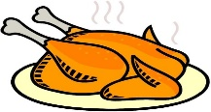  دَجـاج  Dajaj  Chicken | 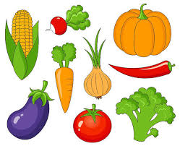  خُـضـار  Khoodar  Vegetables | 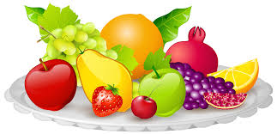  فَـواكِـة  Fawakeh  Fruits
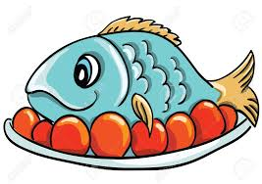  سَـمَـك  Samak  fish | 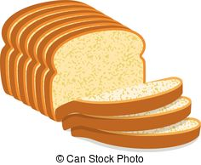  خُـبْـز  Khobz  bread | 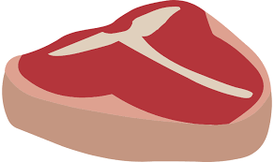  لَـحِـم  Lahem  meat

